# **UNIT 4.6**

# **SYSTEMS ANALYIS & DESIGN**

**TUTOR NAME: MR. ABDI HUBSEY**

**Submitted by: Fatima Ejaz Barri**

Contents

**UNIT 4.6** 1

**SYSTEMS ANALYIS & DESIGN** 1

Task 1 3

1.1 Role of systems analysis and design in systems development 3

1.2 System Development Lifecycle Models 3

1.3 System analysis and redesign of a system 5

1.4 Design methods and methodologies for System Analysis 5

Task 2 6

2.1 Desired Methodology for system design and analysis 6

2.2 Review of different Information gathering techniques 6

2.3 Improvements in the modelling system 6

Task 3 7

3.1 Solution for Modelling Exercise 7

3.2 Evaluation Report 7

References 8

# Task 1

# 1.1 Role of systems analysis and design in systems development

System analysis and design in one of the main steps in the system development. It deals with the planning of information systems development. In this process, system analysts understand what the system should do and specify the details of the working of system components. It seeks to understand how individual components of the system should work together.

Requirements of the system are written down and analyzed in accordance with the needs of the client. Data inputs and outputs, and data flow are also analyzed systematically, in this process.

# 1.2 System Development Lifecycle Models

**Waterfall Model:** This model was the first to be introduced among the SDLC models. It is a simple model in which the process of system development is divided into phases. Each phase each phase needs to be completed before the next phase begins. Output of one phase acts an input of the next one sequentially. There is no overlapping in the phases. This model a sequential design model steadily flows downwards. It is important model for mission critical systems.

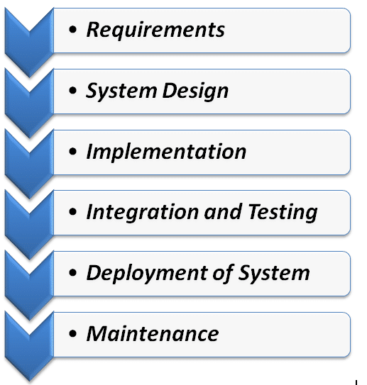

Fig- 1.1- waterfall model.

(toolsqa.com, 2016).

**V-shape Model:** This model is an extension of waterfall model. It is also known as ‘verification and validation model’. Like in waterfall model, phases are executed sequentially in V-shaped model as well. It is a linear and unique system development model in which testing phases are executed in parallel with the development phases. In the end, the development and testing phase are joined together through coding.

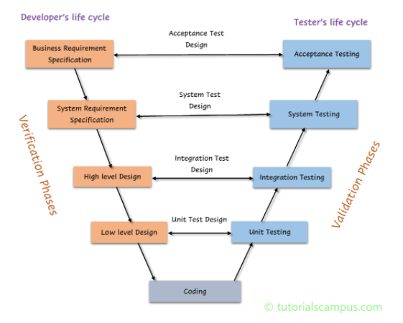

Fig: 1.2- V-shape model.

(tutorialscampus.com)

**Prototyping Model:** In this model, a prototype of the desired system is built until an acceptable prototype that fulfills the client’s requirements is ready. Testing and rework on the prototype is done till then. It also provides as a basis for the final system. It works best for the systems in which the requirements are not clear initially. This process is an iterative process and is based on trial and error approach.

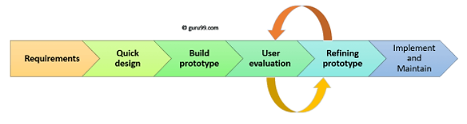

Fig: 1.3- Prototyping model.

(guru99.com)

**Spiral Model:** This model is based on risk driven approach. It is a combination of iterative and waterfall model. It is based on adopting software development elements of different process models and ensuring risk free development. Each phase in this process starts with a design goal and ends with the client’s review of the progress. it starts with a small set of requirements and more functionality is added for additional requirements in the ever increasing spirals until the system is ready for development phase.

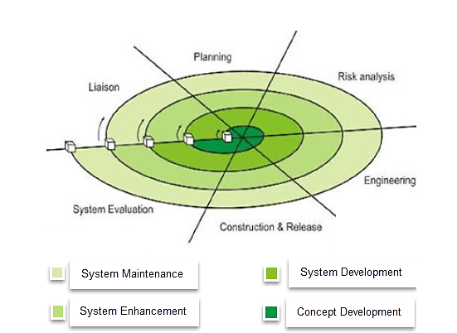

Fig: 1.4- spiral model.

(guru99.com)

# 1.3 System analysis and redesign of a system

System analysis is a very crucial step in the development of the system. In this process, a system is analyzed for its objectives and requirements are documented accordingly. Different models to develop the system are taken into consideration, and the one that suits the requirements of the system is adopted for systems development. Strengths and weaknesses are listed down for each approach for each component of the system. When it comes to the redesign of the system, the documents are analyzed for requirements and the best model is used for development.

# 1.4 Design methods and methodologies for System Analysis

**SSADM:** Structured systems analysis and design (SSADM) is a waterfall model for analyzing and design of software systems. Its applications are in educational institutions, commercial businesses and consultants etc. Like the waterfall model, it starts from the feasibility study to the actual development of the system. In the requirements analysis stage, the users are involved intensely. After the completion of each phase, the users are made sure that all the requirements are being fulfilled. In this method, the project is divided into small modules with defined objective.

**DSDM:** Dynamic systems development method (DSDM) is an agile methodology framework for developing information systems. This framework is an extension of rapid application development method (RAD). This method is based on rapid prototyping along with iterations according to user feedback. This method follows an incremental and iterative approach. Users feedback is taken into great consideration for ongoing improvements. It prioritized scope according to Should Have, Must Have, or Won’t have and relies on quality, strict costs and time constraints.

**Agile:** Agile methodology is one of the most effective and simplest approach for software systems development. This approach applies continual planning, team collaboration, improvement, evolutionary development, learning and early delivery. It is a flexible method and changes according to the changing requirements of the client. Agile methodology employs continuous, iteration, development and testing of the project throughput the software development cycle. The development and testing take place concurrently unlike waterfall model.

# Task 2

# 2.1 Desired Methodology for system design and analysis

Structured systems analysis and design method (SSADM) would a wise choice to build the online hotel reservation system for KLTP Hotel. This model is based on waterfall approach. All the requirements would have to be gathered at the initial stages of the system development. As there are plenty other online hotel reservation systems, they can be used as samples to educate the client about their needs. The involvement of KLTP Hotel team will be most effective in the requirement gathering phase. Once all the requirements are listed and analyzed, the development phase can start.

The stages will be well defined with their individual objectives. The following techniques will be followed for the development

Logical data modeling in system requirements gathering

Data flow modeling to analyze processes, entities, data stores and data flow

Entity Behavior Modeling to identify and document the events sequentially

# 2.2 Review of different Information gathering techniques

Different techniques were used for gathering information about KLTP Hotel reservation system.

**Interviews:** KLTP Hotel team was interviewed to gather requirements for their online system. The interview was structured and the client was presented with open and descriptive format. The result of the process was a success, the client felt comfortable and communicated the requirements effectively. Key problems and hurdles were identified. Ambiguities were also cleared in this process.

**Review of Records, Forms and Procedures:** In this technique, existing records, procedures and forms were reviewed. It helped gaining more insights about the hotel and their operations handling. It gave clear understanding about the transaction procedures and their input and output flow. Performance of the current reservation system was also evaluated for better understanding.

**Observation:** The team f KLTP Hotel was observed and notice to see how they carryout operation and if they would be able to learn about the new online system efficiently. More reliable and accurate data was generated.

# 2.3 Improvements in the modelling system

The modelling system should undergo following improvements

* More user friendly design with easy navigation
* There should be different categories of bedrooms
* Users should be able to categorize rooms on the basis of price and facilities
* The system should be more secure
* The tractions should be speedy and there should be no delay
* There should be two interfaces; for booking by customers and approval by the Hotel admins

# Task 3

# 3.1 Solution for Modelling Exercise

The system’s graphical user interface needs to be welcoming and should give a premium look to the users because they want to stay at the hotel. The system needs to be user friendly and the users should not feel any difficulty while navigating through the system. The users should be able to categorize rooms on the basis of special events, prices, facilities, no of beds etc. so that choosing a room to stay is easy for the users. As the transactions would take place online, the system needs to be very secure. And adopting a waterfall approach will make it possible as this method is more secure than any other. The performance of the system should be speedy and transactions should take place immediately so that there is no room for the third party to interfere. The system should be encrypted for transactions. There should be two interfaces for the system, one for customers for booking and reservations, and the other for hotel admins to update information in the system.

# 3.2 Evaluation Report

The project was divided into phases. The initial requirements were gathered via interviews, observations and review of records, forms and procedures. The stages for the development included:

* Determining feasibility of the system
* Investigation of current environment through observation technique
* Determining operations and business systems
* Creation of logical design
* Creation of physical design

After the defined stages, the feedback was taken from the clients and some recommendations were made in the modelling of system. Based on the analysis, recommendation, requirements and modelling, an evaluation report was generated.

# References

www.mvorganizing.org. (n.d.). *What is the role of system analysis and design? – Mvorganizing.org*. [Online] Available at: <https://www.mvorganizing.org/what-is-the-role-of-system-analysis-and-design/>

[Accessed August 9, 2021].

Sharma, L. (2016). *Waterfall Model in Software Development Life Cycle | SDLC*. [online] Toolsqa.com. Available at: <https://www.toolsqa.com/software-testing/waterfall-model/> [accessed August 9, 2021].

Guru99 (2019). *Prototyping Model in Software Engineering: Methodology, Process, Approach*. [online] Guru99.com. Available at: <https://www.guru99.com/software-engineering-prototyping-model.html> [accessed August 9, 2021].

‌Guru99 (2019). *What is Spiral Model? When to Use? Advantages & Disadvantages*. [online] Guru99.com. Available at: <https://www.guru99.com/what-is-spiral-model-when-to-use-advantages-disadvantages.html> [accessed August 9, 2021].

Techopedia.com. (2019). *What is Structured Systems Analysis and Design Method (SSADM)? - Definition from Techopedia*. [Online] Available at: <https://www.techopedia.com/definition/3983/structured-systems-analysis-and-design-method-ssadm> [accessed August 9, 2021].

The QA Lead. (2020). *What is DSDM (Dynamic Systems Development Method)?* [Online] Available at: <https://theqalead.com/topics/dsdm-dynamic-systems-development-method/> [accessed august 9, 2021].

Tutorialspoint.com. (2020). *System Analysis & Design - System Planning - Tutorialspoint*. [Online] Available at: <https://www.tutorialspoint.com/system_analysis_and_design/system_analysis_and_design_planning.htm> [accessed August 9, 2021].

‌